Internship Week 4 Report

Pranav Gawade D-161 0120180060

* For the week 4 of Inhouse internship under P.V Ugale mam. The task was to research and decide upon shape feature extraction techniques. Upon analysis of various shape extraction techniques, Fourier descriptor was selected. It is an effective way to create a very concise representation of the shapes in the image. It has average computational complexity and is easy to compare with other images. It has been widely used in pattern recognition and in OCR implementations. Although for the purpose of image recognition, the accuracy on the basis of shape alone is not remarkable.

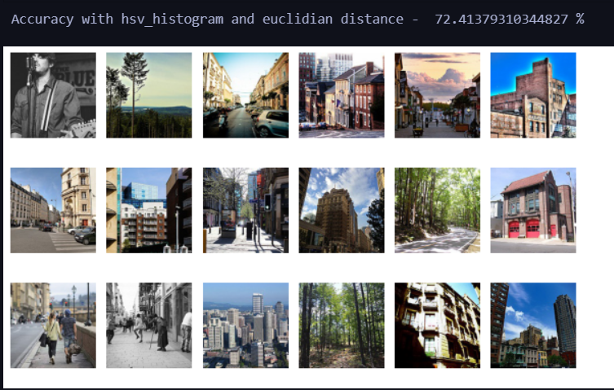

The next logical task would be to combine all the features to give more accurate retrieval results for the given image. Different techniques for integrating features will be tried and the one which gives the best result will be selected.